Practical 1 :

**Software Requirement Specification (SRS)**

**Topic : “Transport Management System.”**

**Limitation of Current System**

* It is done in traditional way.
* It has to be evaluated manually which is prone to calculation mistakes.

**Proposed System**

* By the Computerization of this system all the records can be maintained easily.
* Unlike the manual system particular record can be found easily .There is no need to maintain register.
* The user has to give only the Form no to see any information about particular thing.
* Computerized system contains several forms for different purposes.
* It generates the Proper report of every stage of system.
* The proposed system contain various report like Billing Report, voucher report, employee report, vehicle paper Report, vehicle maintenance report etc.

**FEATURES OF THE PROPOSED SYSTEM**

* All Allowance / Deductions and their formulae can be defined by the management of transport service.
* The search structure is used to find the entries of the database from various fields which makes it more reliable for viewing hierarchal information.
* Time is saved due to faster access to records.
* Validation is done at every level in the system.
* This system is uses MS Access as database, which is strong and secure database for proposed system.
* The proposed system empowers the user with a new computer based system by reducing the efforts of data maintenance.
* The proposed developed according to the user specification hence it is a user-centered system.

**Software and Hardware Requirements**

* **Software Requirements:**

The necessary software required for the development of system is,

* **FRONT END:**

**PHP**

* **BACK END:**

**MY-SQL**

* **Hardware Requirements:**
  + **Minimum Requirements:**

1) Windows 98 Server runs with 12MB of RAM.

2) It doesn’t run until it has 16MB of RAM.

3) It doesn’t shine well until it has 32MB of RAM.

4) Minimum speed needed to run Windows NT is 486.

Practical: 2

**Waterfall Model as the conventional process model to prepare the flow and Gantt Chart using MS-Project.**

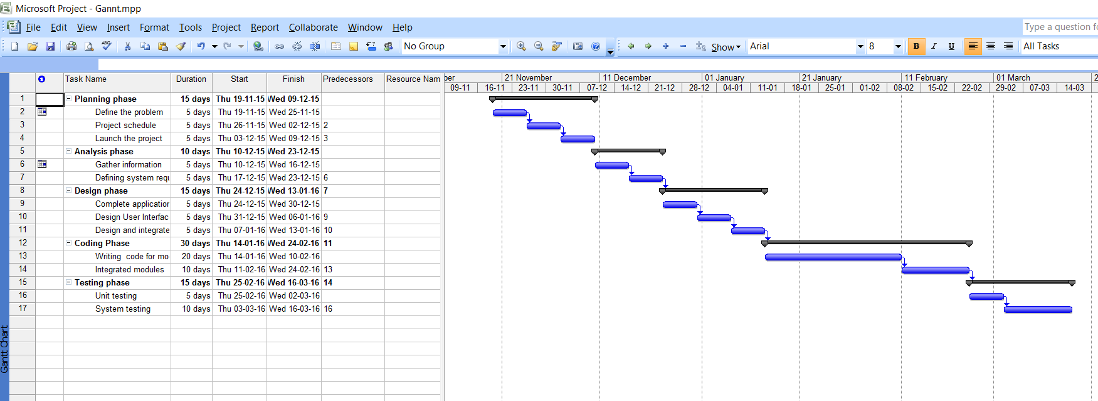

Practical No: 05

**Class Diagram Using Star UML**

**Procedure for creating class:**

**Step 1:**

Launch star UML.

Select the File-> New Project menu.

A new project is created with the default approach selected by the user. Depending on the approach, profiles and/or frameworks may be included / loaded.

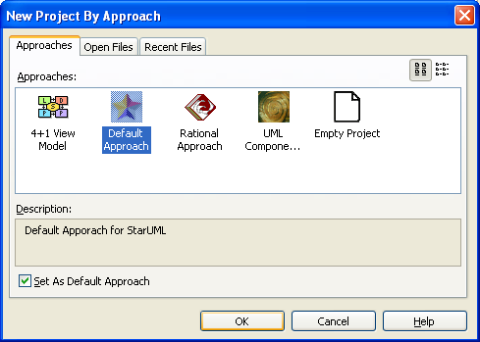

**Step 2:**

Select Model menu from menu bar and then select Add->Design model. In the properties window, give name as class diagram1 (you can specify any name), Stereotype as design Model and visibility as public.

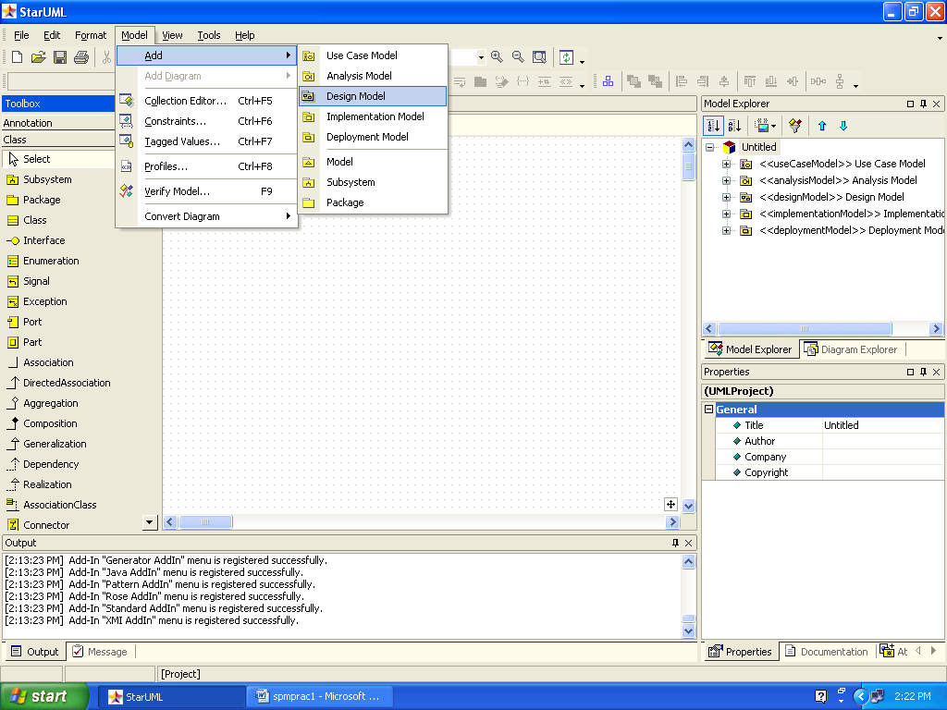

**Step 3:**

Go to model menu->profiles.

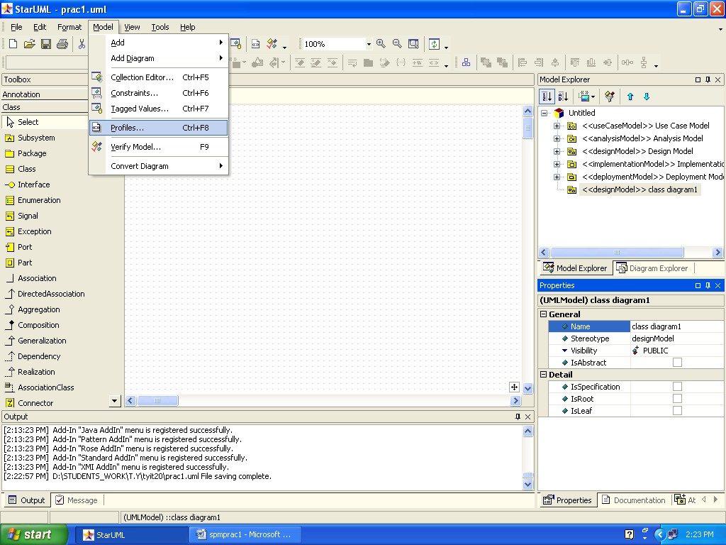

Include java profile on right side.

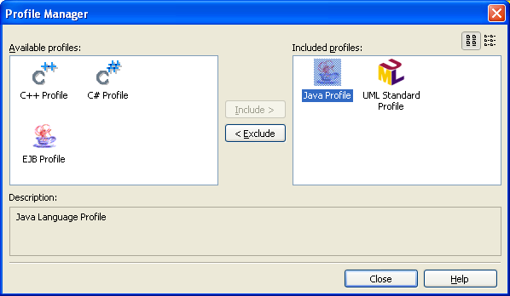

Practical:6

**USE CASE Diagram**

**Step 1:**

Go to model menu in star UML🡪add🡪use case model.

**Step 2:**

Go to model menu in star UML🡪select add diagram🡪use case diagram

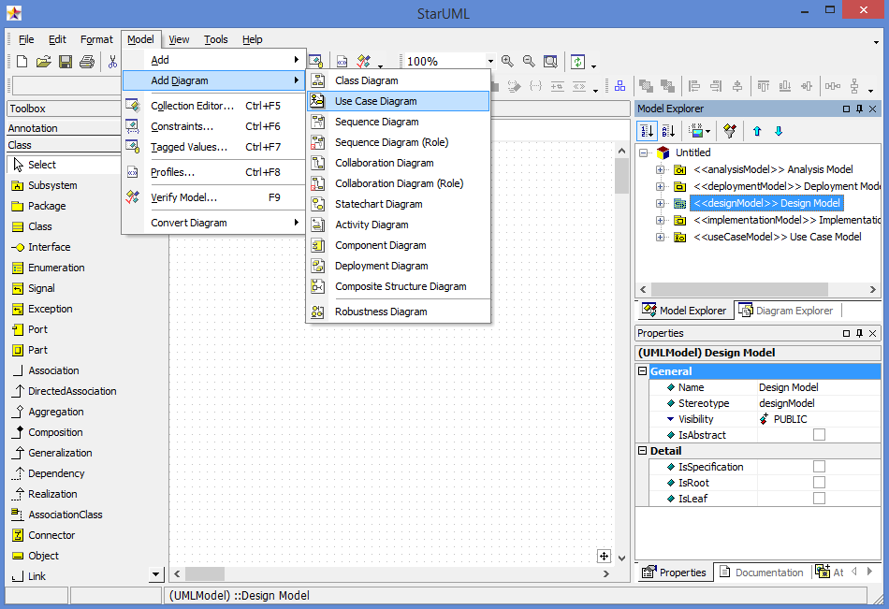

**NOTATIONS USED IN USE-CASE DIAGRAM:**

|  |  |  |
| --- | --- | --- |
| **Usecase** | **Creates a usecase element in the current diagram.** | **UseCase Diagram** |
| Actor | Creates an actor element in the current diagram. | UseCase Diagram |
| System boundary | Creates an system boundary in the current diagram. | UseCase Diagram |
| --------- >  Includes | Links different use cases | Use case diagram |
| Association | Links actor with use cases | Use case diagram |

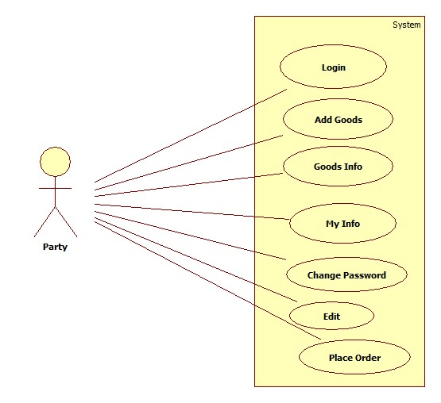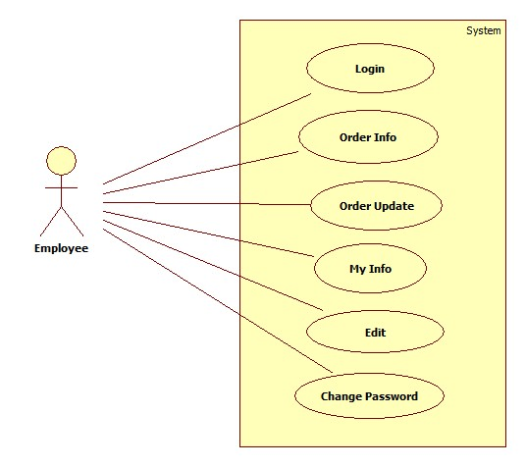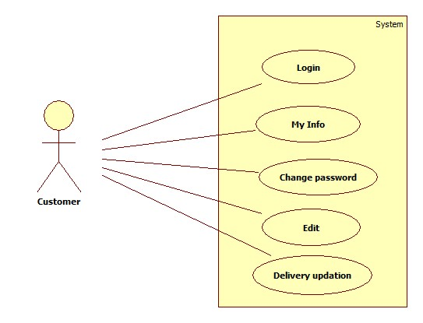

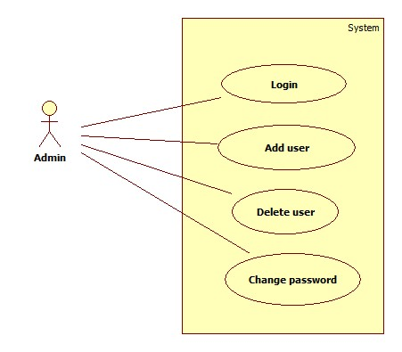

Practical:7

**Activity Diagram**

**Activity Diagram for the prepared Usecase Modelling**

Aim : Derive an activity diagram from the narrative text by following the steps outlined below.

o Translate the above narrative text into an activity list. An activity list consists of a sequences of short sentences in the form of name + verb + noun [+ condition], where the condition is optional. Such sentences are called activities. For example, the following is an activity. ‘the author completes an online form’.

1. Transform each activity in the list into an activity/action node of the activity diagram;

2. Identify the actors involved in the business process, and associate the actors to each action/activity node;

3. Identify the sequential execution order, parallelism/concurrency and synchronisation as well between the actions/activities, and draw the control flows between the action/activity nodes, add synchronisation bar as necessary;

4. Draw a swimlane for each actor and place the action/activity nodes in appropriate swimlane;

5. Identify the objects passed between the activities, and add object nodes and object flows into the diagram.

**Step 1:**

Launch star UML.Select the File-> New Project menu.

A new project is created with the default approach selected by the user. Depending on the approach, profiles and/or frameworks may be included/loaded.

**Step 2:**

Select Model menu from menu bar and then select Add->Design model. In the properties window, give name as class diagram1(you can specify any name), Stereotype as designModel and visibility as public.

**Step 3:**

Right click on design model->add diagram->activity diagram.

**Solution:**

Activity List:

a) The system requests the user to input author name, correspondence address, email and, title of paper if the date is before the deadline.

b) The author completes an online form that contains the data.

c) The system validates this data.

d) The system asks the author to submit the paper, if the data is correct.

e) The author browses his system.

f) The author finds the correct paper on his system.

g) The author submits the paper.

h) The system receives the paper.

i) The system stores the paper.

j) The system assigns a reference number for the paper.

k) The system returns the reference number to the author.

l) The author goes back to activity if they want to submit another paper.

m) System allocates papers to referees for assessment.

n) Referee reviews each paper.

o) Referee submits his assessments to the system.

p) The programme organiser make decisions on each paper’s acceptance.

q) The system emails the author of each paper of the decision.

r) The system creates a schedule for delivering accepted papers at a conference by

allocating a date, time and place for the presentation of each paper.

• The action/activity nodes are marked on the activity list as bold font.

• The actors are the name part of the activities.

• In this exercise, the actions are all sequentially ordered as in the activity list. The parallelism and concurrency only occur in the form of different referees can perform their reviews and assessments in parallel.

• The actors are:

(a) Author; (b) The system; (c) Referee; (d) Conference programme organiser;

• The objects involved in this process are:

(a) Online form; (b) paper; (c) paper’s reference number; (d) assessment report;

(e) Decision; (f) conference schedule.

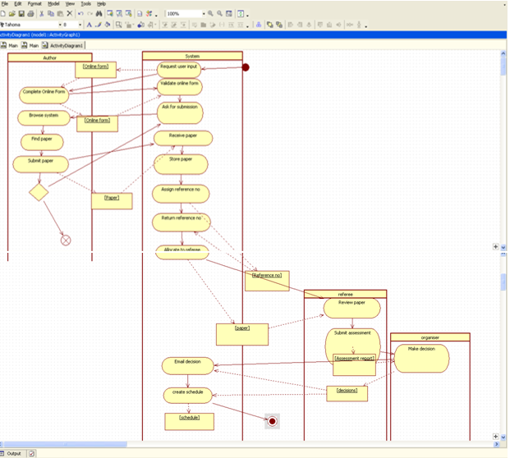

Practical : 8

**Activity description and diagram for the project**

**Step 1:**

Launch star UML.Select the File-> New Project menu.

A new project is created with the default approach selected by the user. Depending on the approach, profiles and/or frameworks may be included/loaded.

**Step 2:**

Select Model menu from menu bar and then select Add->Design model. In the properties window, give name as class diagram1 (you can specify any name), Stereotype as designModel and visibility as public.

**Step 3:**

Right click on design model->add diagram->activity diagram.

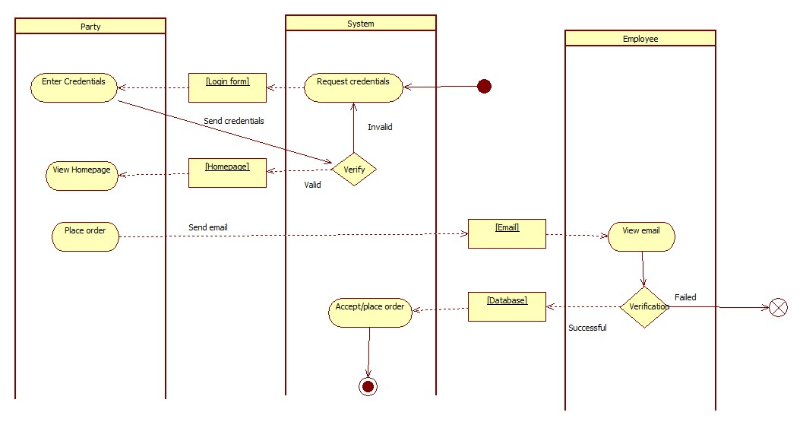

Practical:9

**Work Breakdown Structure for the given Project**

Q.) Create a work breakdown structure as shown below:

**Solution:**

**Step 1:**

Launch WBS chart pro. Select the arrow shown below for inserting new task.

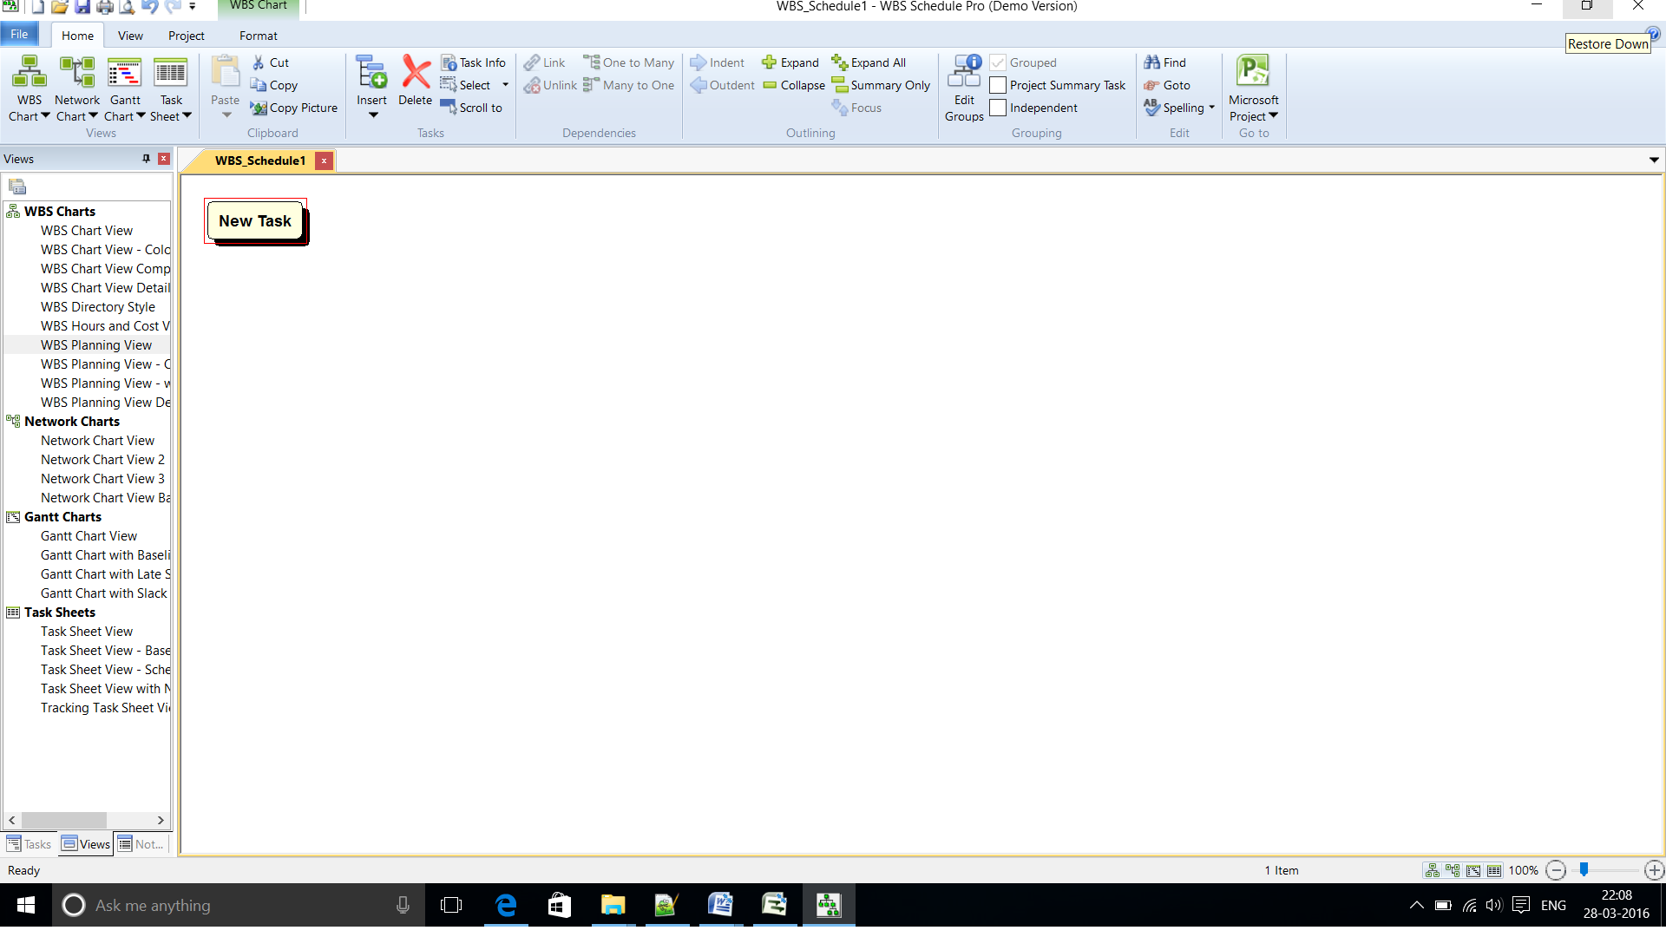

**Step 2:**

Double click on the task shown above and give the name for the task.

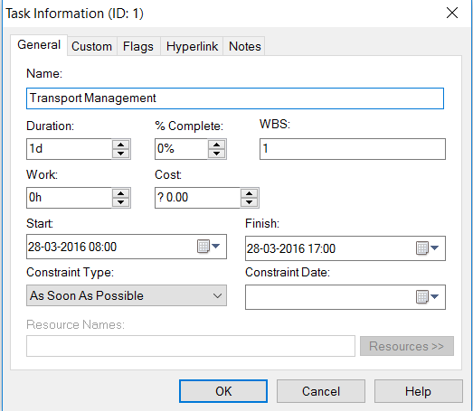

**Step 3:**

Continue to add the tasks. We can also add subtasks for a given task.

**WBS chart view**

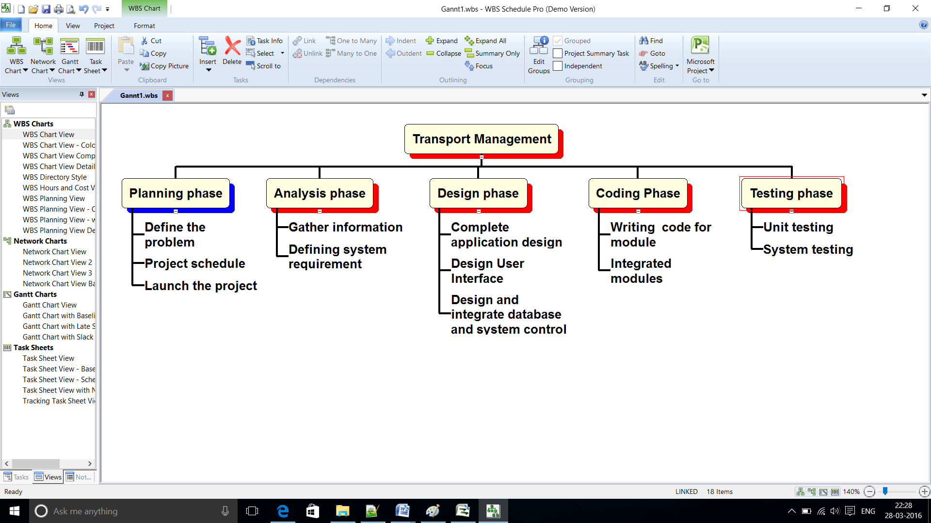

**Planning view of Transport Management**

